**HTML Task to know usage of basic tags.**

1. **Fix the bugs in below snippet**

<html lang="en">

<head>

<title>Document

<body>

guvi

</title>

</head>

<div>

Lorem ipsum dolor sit amet consectetur adipisicing elit.

<div>

<div>

Guvi Geek Network

</div>

</body>

</html>

**Solution:**

<html lang="en">

<head>

<title>Document</title>guvi

</head>

<body>

<div> Lorem ipsum dolor sit amet consectetur adipisicing elit.</div>

<div> Guvi Geek Network</div>

</body>

</html>

1. **Try the below one**

<html lang="en">

<head>

<title>Document

<body>

guvi

</head>

<div>

Lorem ipsum dolor sit amet consectetur adipisicing elit.

<div>

<div>

Guvi Geek Network

</div>

</body>

</html>

**Solution:**

<html lang="en">

<head>

<title>Document</title>

guvi

</head>

<body>

<div>

Lorem ipsum dolor sit amet consectetur adipisicing elit.

</div>

<div>

Guvi Geek Network

</div>

</body>

</html>

1. **Design a contact us form with all fields as required.**

**Solution:**

<!DOCTYPE html>

<html lang="en">

<head>

    <meta charset="UTF-8">

    <meta http-equiv="X-UA-Compatible" content="IE=edge">

    <meta name="viewport" content="width=device-width, initial-scale=1.0">

    <title>Contact us</title>

    <style>

        .card{

            border: rgb(66, 191, 223) solid 2px;

            margin-left: 400px;

            margin-right: 400px;

            margin-top: 30px;

            background-color: rgb(230, 236, 238);

        }

    </style>

</head>

<body>

    <div class="card">

        <form action="GET">

            <center><h1>Contact us</h1></center>

            <div style="display: inline-block; margin-left: 80px;">

                <div style="display: inline-block;">

                    <label for="fname">First Name</label><br>

                    <input type="text" id="fname" required>

                </div>

                <div style="display: inline-block; margin-left: 20px;">

                    <label for="lname">Last Name</label><br>

                    <input type="text" id="lname" required >

                </div>

             </div><br><br>

            <div style="margin-left: 80px;">

                <label for="phoneno" style="margin-right: 50px;">Phone Number</label>

                <input type="phone number" id="phoneno" required >

            </div><br>

            <div style="margin-left: 80px;">

                <label for="email" style="margin-right: 86px;">Email ID</label>

                <input type="email" name="email" id="email" required >

            </div><br>

            <div style="margin-left: 80px;">

                <label for="" style="margin-right: 118px;">Age</label>

                <input type="number" name="" id="" required>

            </div><br>

            <div style="margin-left: 80px;">

                <label for="" style="margin-right: 92px;">Address</label>

                <textarea name="" id="" cols="30" rows="4"></textarea>

            </div><br>

            <div style="margin-left: 80px;">

                <label for="" style="margin-right: 51px;">College Name</label>

                <input type="text" name="" id="" required >

            </div><br>

            <div style="margin-left: 80px;">

                <label for="" style="margin-right: 67px;">Department</label>

                <input type="text" name="" id="" required >

            </div><br>

            <div style="margin-left: 80px;">

                <label for="" style="margin-right: 95px;">CGPA*</label>

                <input type="number" name="" id="" required >

            </div><br>

            <div style="text-align: center;">

                <input type="submit" value="submit" style="width: 80px;" required >

            </div><br>

        </form>

    </div>

</body>

</html>

**Output:**

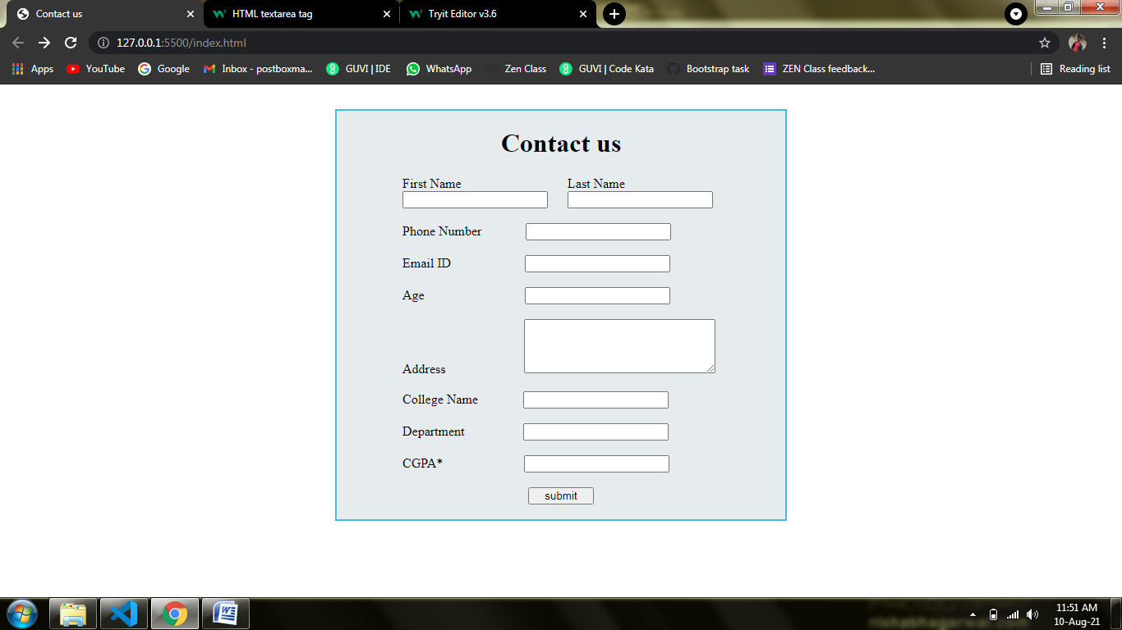

1. Use certain HTML elements to display the following in a HTML page.

Solution:

<ul>

         <li>

            Programming Language

            <ul style="list-style-type: circle;">

                <li>

                    JavaScript

                    <ol type="a">

                        <li>Angular</li>

                        <li>React</li>

                        <li>Vue.js</li>

                    </ol>

                </li>

                <li>

                    Python

                    <ol type="a">

                        <li>Django Framework</li>

                        <li>Flask Framework</li>

                    </ol>

                </li>

                <li>

                    Java

                    <ol type="a">

                        <li>Spring</li>

                        <li>Maven</li>

                        <li>Hibernate</li>

                    </ol>

                </li>

            </ul>

         </li>

         <li>

            Database

            <ul type="circle">

                <li>MySQL</li>

                <li>MongoDB</li>

                <li>Cansandra</li>

            </ul>

         </li>

     </ul>

1. Create an element that helps you to open the [https://google.com](https://google.com/) in separate new tab.

Solution:

<a href="https://google.com" target="_blank">https://google.com</a>

1. In the form, add two radio buttons with grouping them for employee type(Salaried and own business)

Solution:

<div class="card">

        <form action="GET">

            <center><h1>Employee Details</h1></center>

            <div style="display: inline-block; margin-left: 80px;">

                <div style="display: inline-block;">

                    <label for="name">Name</label><br>

                    <input type="text" id="name">

                </div>

                <div style="display: inline-block; margin-left: 20px;">

                    <label for="Area">Area</label><br>

                    <input type="text" id="Area">

                </div>

             </div><br><br>

             <div style="margin-left: 120px;">

                    <label for="emp" style="margin-right: 20px;">Salaried</label>

                    <input type="radio" name="Salaried" id="emp">

                    <label for="emp" style="margin-left: 60px; margin-right: 20px;">Own Business</label>

                    <input type="radio" name="Own Business" id="emp">

            </div><br>

            <div style="text-align: center;">

                <input type="submit" value="submit" style="width: 80px;">

            </div><br>

        </form>

    </div>

Output:

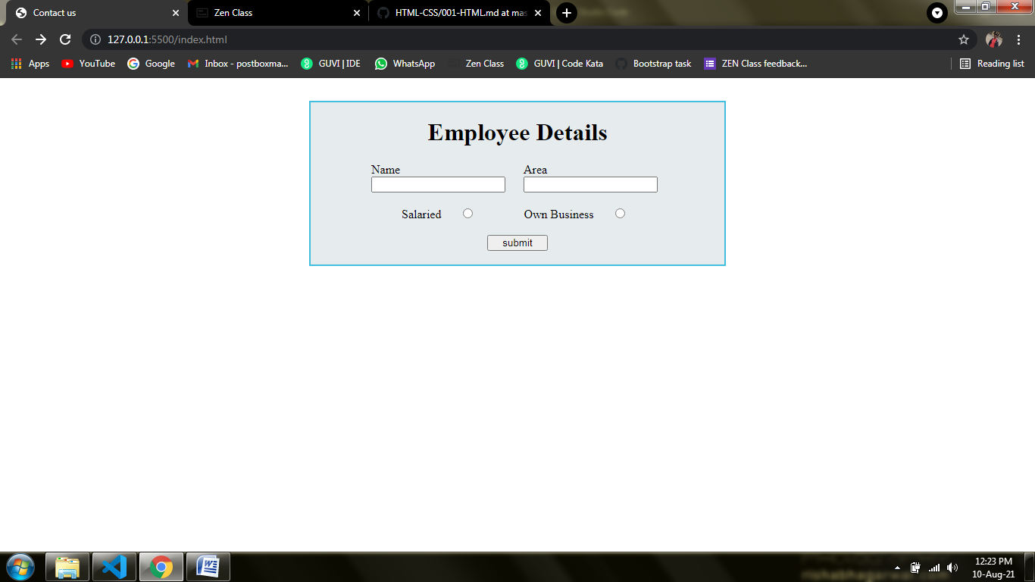

1. Design form shown in the link (<http://evc-cit.info/cit040/formguide/card_0.png>)

**Solution:**

 <div class="card">

        <div style="background-color: white; padding:5px 5px;">

            <div style="border: 2px solid black;">

                <div style="background-color: red; margin: 5px 5px; color: white; padding: 5px 5px; text-align: center;">

                   Yes! I want to subscribe to <span style="font-style: italic; font-weight: bolder;">Mag-O-zine</span>

                </div> <br>

                <div style="display: inline-block; margin-left: 10px;">

                    <div style="display: inline-block;">

                        <input type="text" name="" id="" size="30"><br>

                        <label for="">First Name</label>

                    </div>

                    <div style="display: inline-block; margin-left: 30px;">

                        <input type="text" name="" id="" size="30"><br>

                        <label for="">Last Name</label>

                    </div>

                </div>

                <div style="margin-left: 10px;">

                    <input type="text" name="" id="" size="70"><br>

                    <label for="">Address</label>

                </div>

                <div style="display: inline-block; margin-left: 10px;">

                    <div style="display: inline-block;">

                        <input type="text" name="" id="" size="20"><br>

                        <label for="">City</label>

                    </div>

                    <div style="display: inline-block; margin-left: 15px;">

                        <input type="text" name="" id="" size="15"><br>

                        <label for="">State</label>

                    </div>

                    <div style="display: inline-block; margin-left: 9px;">

                        <input type="text" name="" id="" size="20"><br>

                        <label for="">Zip</label>

                    </div>

                </div>

                <div style="font-weight: bold; margin-left: 10px;">

                   Subscribe for: <input type="checkbox" name="" id=""> 1 year ($19.95)

                   <input type="checkbox" name="" id=""> 2 years ($35.00)

                </div>

                <div style="font-weight: bold; margin-left: 10px;">

                    Send me more information about:

                </div>

                <div style="font-weight: bold; margin-left: 15px;">

                    <input type="checkbox" name="" id="">

                    <label for="">Computer-Zine</label><br>

                    <input type="checkbox" name="" id="">

                    <label for="">Fishing-Zine</label><br>

                    <input type="checkbox" name="" id="">

                    <label for="">Cat-O-Zine</label>

                </div>

            </div>

        </div>

    </div>

**Output:**

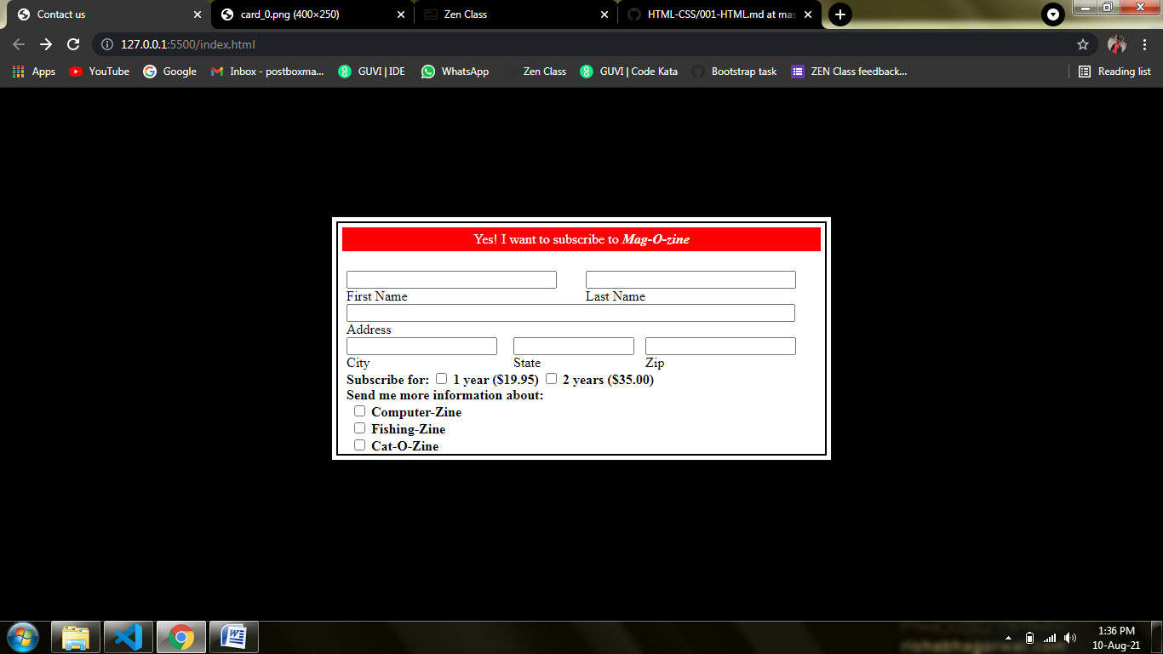

1. **Use the table tag to design given image**[**Click here**](https://www.bapugraphics.com/assets/img/port_upload_dir/table-4.jpg)**.**

**Solution:**

<!DOCTYPE html>

<html lang="en">

<head>

<meta charset="UTF-8">

<meta http-equiv="X-UA-Compatible" content="IE=edge">

<meta name="viewport" content="width=device-width, initial-scale=1.0">

<title>HTML Practice</title>

<style>

table,th,td{

border:2px solid black;

border-collapse: collapse;

text-align: center;

padding:10px;

}

</style>

</head>

<body>

<table>

<tr>

<th>State of Health</th>

<th colspan="2">Fasting Value</th>

<th>After Remaining</th>

</tr>

<tr>

<th> </th>

<th>Minimum</th>

<th>Normal</th>

<th>2hr of Eating</th>

</tr>

<tr>

<td>healthy</td>

<td>70</td>

<td>100</td>

<td>less than 140</td>

</tr>

<tr>

<td>Pre-Diabetes</td>

<td>101</td>

<td>126</td>

<td>140 to 200</td>

</tr>

<tr>

<td>Diabetes</td>

<td>More than 126</td>

<td>Not Applicable</td>

<td>More than 200</td>

</tr>

</table>

</body>

</html>

**Output:**

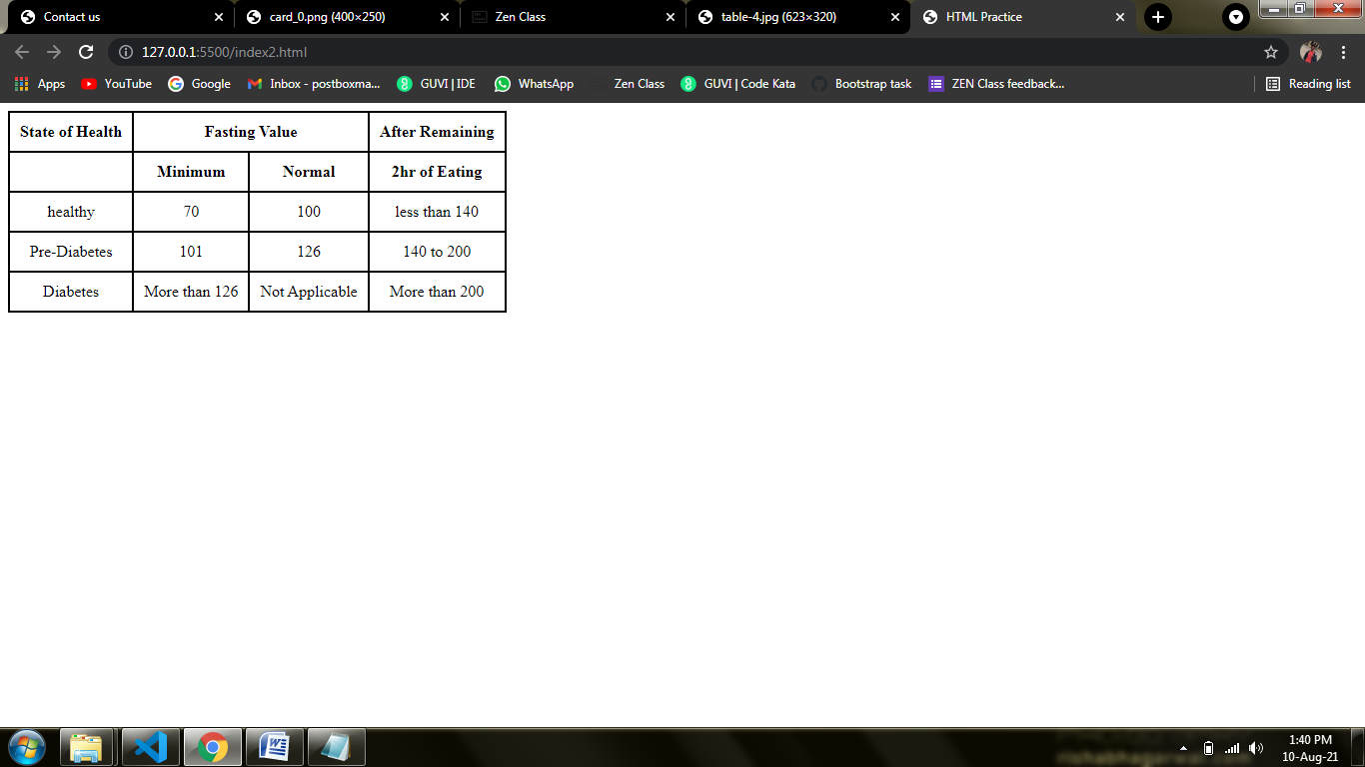

1. **Write HTML input tags snippet to show default values for all Form elements.**

**Solution:**

    <div class="card">

        <form action="GET">

            <center><h1>Contact us</h1></center>

            <div style="display: inline-block; margin-left: 80px;">

                <div style="display: inline-block;">

                    <label for="fname">First Name</label><br>

                    <input type="text" id="fname">

                </div>

                <div style="display: inline-block; margin-left: 20px;">

                    <label for="lname">Last Name</label><br>

                    <input type="text" id="lname">

                </div>

            </div><br><br>

            <div style="display: inline-block; margin-left: 80px;">

                <div style="display: inline-block;">

                    <label for="fname">Email id:</label>

                    <input type="email" name="" id="">

                </div>

            </div><br><br>

            <div style="display: inline-block; margin-left: 80px;">

                <div style="display: inline-block;">

                    <label for="fname">Graduation:</label>

                    <input type="checkbox" name="" id="">

                    <label for="">Engineering</label>

                    <input type="checkbox" name="" id="">

                    <label for="">Arts</label>

                </div>

            </div><br><br>

            <div style="display: inline-block; margin-left: 80px;">

                <div style="display: inline-block;">

                    <label for="fname">Your Fav Color</label>

                    <input type="color" name="" id="">

                </div>

            </div><br><br>

            <div style="display: inline-block; margin-left: 80px;">

                <div style="display: inline-block;">

                    <label for="fname">DOB: </label>

                    <input type="date" name="" id="">

                </div>

            </div><br><br>

            <div style="display: inline-block; margin-left: 80px;">

                <div style="display: inline-block;">

                    <label for="fname">Your Birth Time:</label>

                    <input type="datetime-local" name="" id="">

                </div>

            </div><br><br>

            <div style="display: inline-block; margin-left: 80px;">

                <div style="display: inline-block;">

                    <label for="fname">Upload 10th:</label>

                    <input type="file" name="" id="">

                </div>

            </div><br><br>

            <div style="display: inline-block; margin-left: 80px;">

                <div style="display: inline-block;">

                    <label for="fname">Hidden Area</label>

                    <input type="hidden" name="Hi">

                </div>

            </div><br><br>

            <div style="display: inline-block; margin-left: 80px;">

                <div style="display: inline-block;">

                    <label for="fname">Your Photo</label>

                    <input type="image" src="https://www.collinsdictionary.com/images/full/river_377603497_1000.jpg" alt="river" width:"50px" height="50px">

                </div>

            </div><br><br>

            <div style="display: inline-block; margin-left: 80px;">

                <div style="display: inline-block;">

                    <label for="fname">Joining Month</label>

                    <input type="month" name="" id="">

                </div>

            </div><br><br>

            <div style="display: inline-block; margin-left: 80px;">

                <div style="display: inline-block;">

                    <label for="fname">Phone number</label>

                    <input type="number" name="" id="">

                </div>

            </div><br><br>

            <div style="display: inline-block; margin-left: 80px;">

                <div style="display: inline-block;">

                    <label for="fname">Gender: </label>

                    <input type="radio" name="" id="">

                    <label for="">Male</label>

                    <input type="radio" name="" id="">

                    <label for="">Female</label>

                </div>

            </div><br><br>

            <div style="display: inline-block; margin-left: 80px;">

                <div style="display: inline-block;">

                    <label for="fname">Your Technical Skill:</label>

                    <input type="range" name="" id="">

                </div>

            </div><br><br>

            <div style="display: inline-block; margin-left: 80px;">

                <div style="display: inline-block;">

                    <label for="fname">Searching</label>

                    <input type="search" name="" id="">

                </div>

            </div><br><br>

            <div style="display: inline-block; margin-left: 80px;">

                <div style="display: inline-block;">

                    <label for="fname">Feedback</label>

                    <input type="tel" name="" id="">

                </div>

            </div><br><br>

            <div style="display: inline-block; margin-left: 80px;">

                <div style="display: inline-block;">

                    <label for="fname">Your Office Time: </label>

                    <input type="time" name="" id="">

                </div>

            </div><br><br>

            <div style="display: inline-block; margin-left: 80px;">

                <div style="display: inline-block;">

                    <label for="fname">Give Your Portfolio</label>

                    <input type="url" name="" id="">

                </div>

            </div><br><br>

            <div style="display: inline-block; margin-left: 80px;">

                <div style="display: inline-block;">

                    <label for="fname">Your week off day:</label>

                    <input type="week" name="" id="">

                </div>

            </div><br><br>

            <center><input type="submit" value="Submit"><input type="reset" value="Reset"></center>

        </form>

    </div>

**Output:**

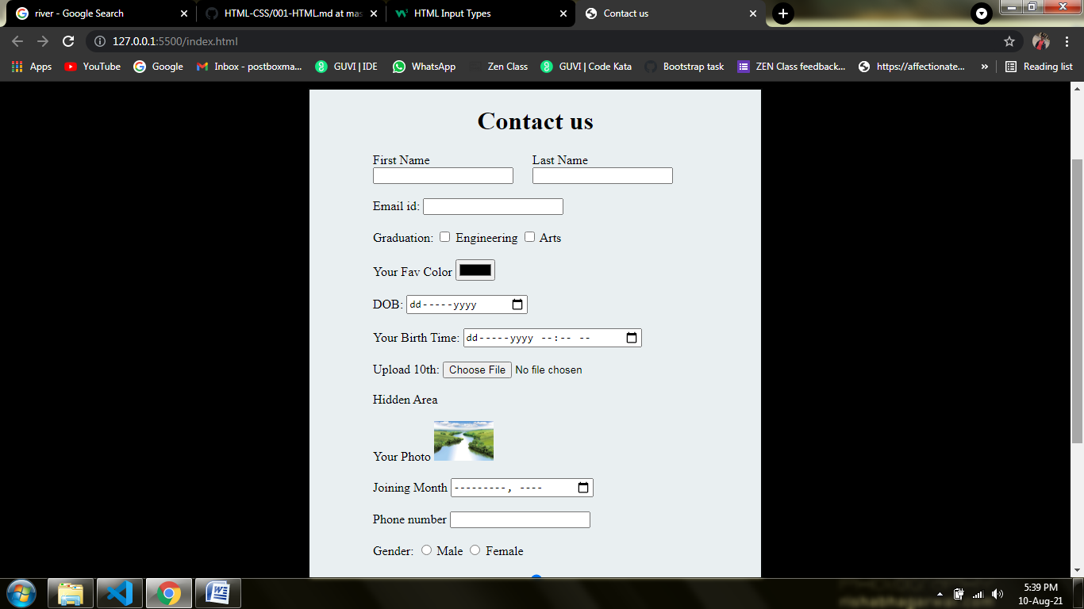

1. **In your, HTML page add the below line and Highlight it without using any CSS.**

* **"HTML & CSS is awesome"**

**Solution:**

 <ul>

        <li><h2><i><u>HTML & CSS is awesome</u></i></h2></li>

    </ul>